# Chapter 4: PROJECT PLANNING

## 4.1 Work Breakdown Structure (WBS)

It is the process to divide difficult project into simple adaptable task. Since, this project has many task and requirement to meet and it has become complex. Therefore, WBS is perform to breakdown the project into the small parts to make it easier and maintain efficiency. Some step addresses in the WBS are as follows:

* Proposal
* Analysis
* Design
* Implementation
* Testing
* Reporting

Figure 4 work breakdown structure (WBS)

## 4.2 Milestones

A milestone is the management tool that is use to define the point in a project schedule. Therefore, while doing project milestone can help enormously scheduling. Milestones are commonly find in the project management.

|  |  |
| --- | --- |
| **Milestones** | **Date ( year-2019)** |
| Project proposal   * Brainstorming * Planning * Scoping * Risk management * Configuration management | 25th March - 9th April (16 days)   * 2 days * 7 days * 3 days * 2 days * 1 day |
| Analysis   * Feasibility study * Requirements gathering * System Requirement Specification * Functional requirement * Non-functional requirement * Use case diagram | 10th April - 8th May (29 days)   * 1 day * 8 days * 10 days * 6 days * 4 days * 8 days |
| Design   * Initial class Diagram * Final diagram * Data flow diagram * ER diagram * Behavioural Design * activity diagram * sequential diagram * UI Design * Front end Design * back end design | 9th May - 3rd June (26 days)   * 4 days * 4 days * 2 days * 2 days * 4 days * 2 days * 2 days * 9 days * 4 days * 5 days |
| Implementation   * Database Building * Coding | 4th June - 24th June (21 days)   * 13 days * 8 days |
| Testing   * Black and white box testing * Integrated testing | 25th June - 1st July (7 days)   * 4 days * 3 days |
| Final Document   * documentation | 2nd July - 12th July (11 days)   * 11 days |

Figure 5 Milestones Scheduling

In the above table, its task and the deadline are mentioned firstly in project proposal, which is 9th April. Likewise, analysis deadline is 8th may, design deadline is 3rd June, implementation deadline is 24th June, testing deadline is 1st July and final document is 12th July.

# 4.3 Gantt Chart

To track the project schedule we are going to use Gantt chart. It is useful to show the various task or phases.

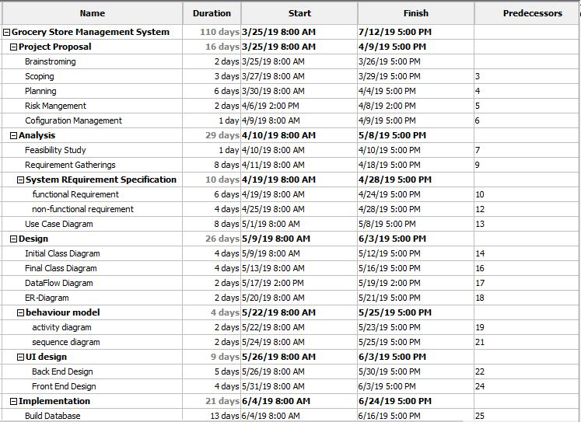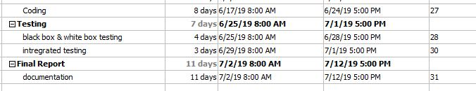

Figure 6: time estimated scheduling

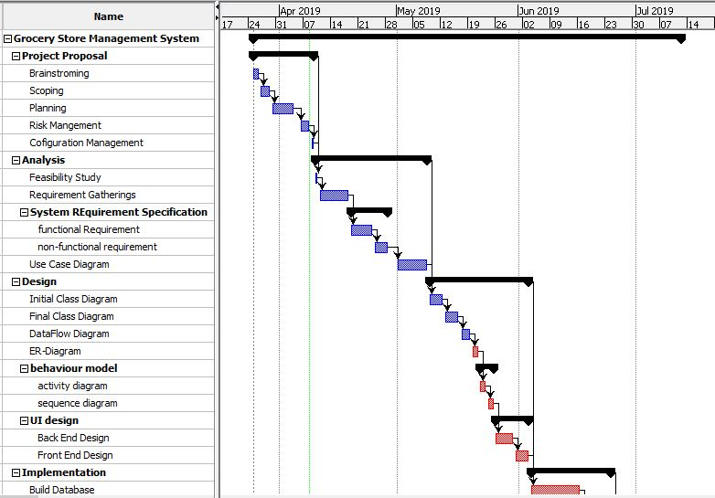 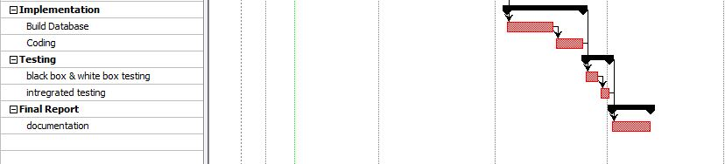

Figure 7 : Gantt chart for time estimated